**FOOTBALL NEWS WEBSITE**

A dissertation submitted in partial fulfillment

of the requirements for the degree of

**Bachelor of Technology**

**In**

**Computer Science & Engineering**

**By**

**Team GoFootball**

Rahul Kamath – 13BCE1104

Hari A– 13BCE1047

Varun Vedant – 13BCE1167

**Faculty Name -** Prof. Sandhya **Slot –** F1



School of Computing Science & Engineering

VIT University Chennai

Vandalur-Kelambakkam Road,

Chennai – 600127,India

**APRIL 2016**

**Aim:**

To Design a website which displays Football News and information about various teams using HTML,CSS, Javascript and Python

**Abstract:**

A website to read news about your favorite football teams and get squad updates of 8 teams .It also allows the user to view the latest news,most popular news,sort news by date and popularity.It also has a RSS feed module ,where the website fetches data from other reliable sources and posts them in a neat customized format .This project uses Google App Engine to host the website online.

**Additional Features :**

This website allows the user to see the number of views per post ,so that he will have an idea of the popularity of the post and also allows him to see the top 6 popular news based on the number of views

**USE CASE DIAGRAM:**

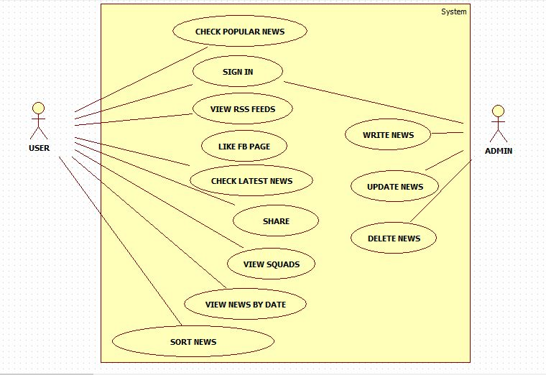

**HARDWARE and SOFTWARE REQUIREMENTS :**

|  |  |  |
| --- | --- | --- |
| **Operating System** | **Recommended Requirements** | **Minimum Requirements** |
| **Windows** | 2nd-generation Core i5 (2GHz+), 3rd/4th-generation Core i5 processor, or equivalent;  Windows 7 or later | Core i3 or equivalent  Windows Vista or later |
| **Apple OS X** | Macbook Pro 2011 or newer, Macbook Air 2012 or newer;  OS X 10.9 or above | Macbook Pro 2010, Macbook Air 2011;  OS X 10.7 or above |
| **Chrome OS** | All 2014 models and later, 2013 Haswell-based models, and Samsung Chromebook 2 | Not applicable |
| **Linux** | Results will vary depending on OS distribution, driver support, and desktop environment |  |

**BROWSERS:**

* **Chrome**
* **Firefox**
* **Windows only**: Internet Explorer
* **Mac only**: Safari

**CODE:**

**Project.html**

**FRONT PAGE**

<!DOCTYPE html>

<!--

To change this license header, choose License Headers in Project Properties.

To change this template file, choose Tools | Templates

and open the template in the editor.

-->

<html>

<head>

<title>Counter Attack Football</title>

<meta charset="UTF-8">

<meta name="viewport" content="width=device-width, initial-scale=1.0">

<meta name="google-signin-client_id" content="636222690890-s7qdqru8kkk7v349r333i74q2a01btk5.apps.googleusercontent.com">

<link rel="stylesheet" type="text/css" href="/styles/Project.css" />

<!-- Latest compiled and minified CSS -->

<link rel="stylesheet" href="https://maxcdn.bootstrapcdn.com/bootstrap/3.3.6/css/bootstrap.min.css" integrity="sha384-1q8mTJOASx8j1Au+a5WDVnPi2lkFfwwEAa8hDDdjZlpLegxhjVME1fgjWPGmkzs7" crossorigin="anonymous">

<!-- Optional theme -->

<link rel="stylesheet" href="https://maxcdn.bootstrapcdn.com/bootstrap/3.3.6/css/bootstrap-theme.min.css" integrity="sha384-fLW2N01lMqjakBkx3l/M9EahuwpSfeNvV63J5ezn3uZzapT0u7EYsXMjQV+0En5r" crossorigin="anonymous">

<script>

function onSignIn(googleUser) {

var profile = googleUser.getBasicProfile();

console.log('ID: ' + profile.getId()); // Do not send to your backend! Use an ID token instead.

console.log('Name: ' + profile.getName());

console.log('Image URL: ' + profile.getImageUrl());

console.log('Email: ' + profile.getEmail());

document.getElementById('signoutbox').style.visibility = "visible";

document.getElementById('namebox').style.visibility = "visible";

x = profile.getName();

y= x.toUpperCase();

document.getElementById('namebox').value = y;

}

function signOut() {

var auth2 = gapi.auth2.getAuthInstance();

auth2.signOut().then(function () {

console.log('User signed out.');

document.getElementById('signoutbox').style.visibility = "hidden";

document.getElementById('namebox').style.visibility = "hidden";

});

}

</script>

</head>

<body >

<div id="fb-root"></div>

<script>(function(d, s, id) {

var js, fjs = d.getElementsByTagName(s)[0];

if (d.getElementById(id)) return;

js = d.createElement(s); js.id = id;

js.src = "//connect.facebook.net/en_GB/sdk.js#xfbml=1&version=v2.6";

fjs.parentNode.insertBefore(js, fjs);

}(document, 'script', 'facebook-jssdk'));

</script>

<script src="https://apis.google.com/js/platform.js" async defer>

</script>

<nav class="navbar navbar-inverse ">

<div class="container-fluid abc" >

<ul class="nav navbar-nav ">

<li><a class = "active" style = "color:white;" href="/">HOME</a></li>

<li><a style = "color:white;" href="/teams">TEAMS</a></li>

</li>

<li><a style = "color:white;" href="/news">NEWS</a></li>

<li><a style = "color:white;" href="/popular">POPULAR</a>

</li>

</ul>

<ul class="nav navbar-nav navbar-right">

<li class="dropdown">

<a class="dropdown-toggle" style = "color:white;" data-toggle="dropdown" href="#">OTHERS<span class="caret"></span> </a>

<ul class="dropdown-menu" style= "background-color: #111111;" >

<li><a style = "font-weight: 700;color: #ffa600;" href="/allnews">ALL NEWS</a></li>

<li><a style = "font-weight: 700;color: #ffa600;" href="/eplnews">PREMIER LEAGUE</a></li>

<li><a style = "font-weight: 700;color: #ffa600;" href="/uclnews">CHAMPIONS LEAGUE</a></li>

<li><a style = "font-weight: 700;color: #ffa600;" href="/Internationalnews">INTERNATIONAL</a></li>

</ul>

</li>

<li><a style = "color:white;" href="/about"> ABOUT</a></li>

<input id = "namebox" type = "text" value = "" readonly> <li> <a href="#" id="signoutbox" onclick="signOut();">SIGN OUT</a>

</li>

</ul>

</div>

</nav>

<div class="container"> <div class="col-lg-12">

<script></script>

<div class="g-signin2" data-onsuccess="onSignIn"></div>

<div id="fb-root"></div>

<script>(function(d, s, id) {

var js, fjs = d.getElementsByTagName(s)[0];

if (d.getElementById(id)) return;

js = d.createElement(s); js.id = id;

js.src = "//connect.facebook.net/en_GB/sdk.js#xfbml=1&version=v2.6";

fjs.parentNode.insertBefore(js, fjs);

}(document, 'script', 'facebook-jssdk'));</script>

<div class ="article">

<div class = "frontpagetitle" ><marquee scrollamount="15">LATEST HEADLINES</marquee></div>

<div class = "row">

{% for article in adata %}

<div class = "col-lg-4">

<div class = "article-picture">

<a href ="/news/{{article.key().id()}}">

<img class= "hpmain" src="{{article.picture}}" alt= "Image not Found" style = "width: 100%; height: 80%; align: center;">

</a><div class = "article-headlinemain"><a href ="/news/{{article.key().id()}}">{{article.headline}}</a></div>

</div>

</div>

{% endfor %}

<div class="fb-like" data-href="http://counter-attack-football.appspot.com/" data-layout="standard" data-action="like" data-show-faces="true" data-share="true"></div>

</div>

</div>

</div>

</div>

<script src="https://code.jquery.com/jquery-1.12.2.min.js"></script>

<script src="https://maxcdn.bootstrapcdn.com/bootstrap/3.3.6/js/bootstrap.min.js" integrity="sha384-0mSbJDEHialfmuBBQP6A4Qrprq5OVfW37PRR3j5ELqxss1yVqOtnepnHVP9aJ7xS" crossorigin="anonymous"></script>

</body>

</html>

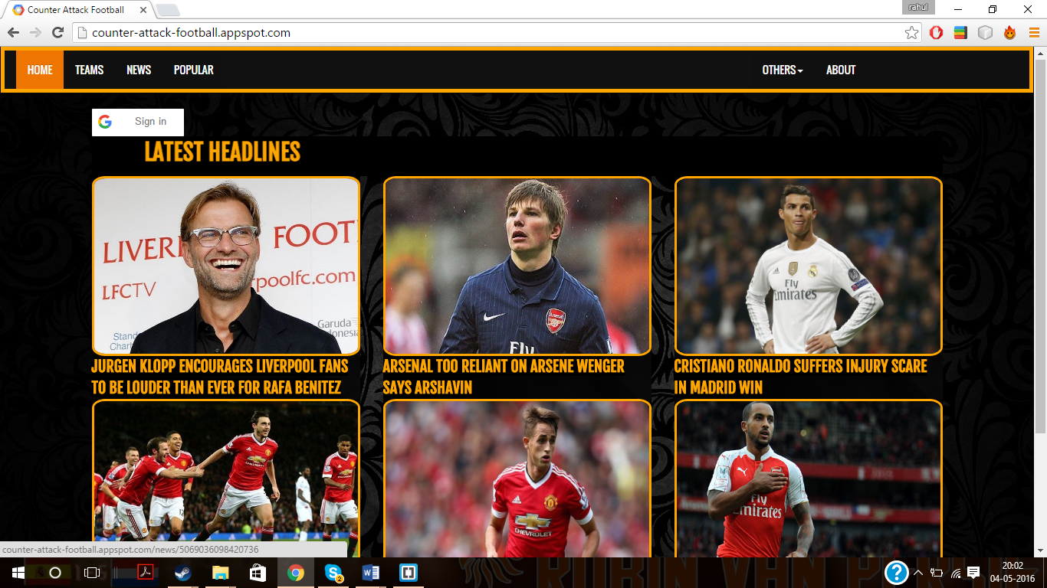

**NEWS TEMPLATE:**

<div class="col-lg-12">

<div class="g-signin2" data-onsuccess="onSignIn"></div>

<div class ="NewsTemp">

<div class = "row">

<div class = "article-sideheadline1">{{data.headline}}</div></div>

<div class = "article-created">{{data.created}}</div>

<div class = "article-author">by {{data.author}}</div>

<div class ="row"> <div class = "newstemp-picture"><img class = "hp" src="{{data.picture}}" alt= "Image not Found" style = "width: 60%; height: 400"></div></div>

<div class = "row"><div class = "article-sideheadline">{{data.sideheadline}}</div></div>

<div class = "row"><div class = "article-content">{{data.content}}</div></div>

</div>

</div>

</div> 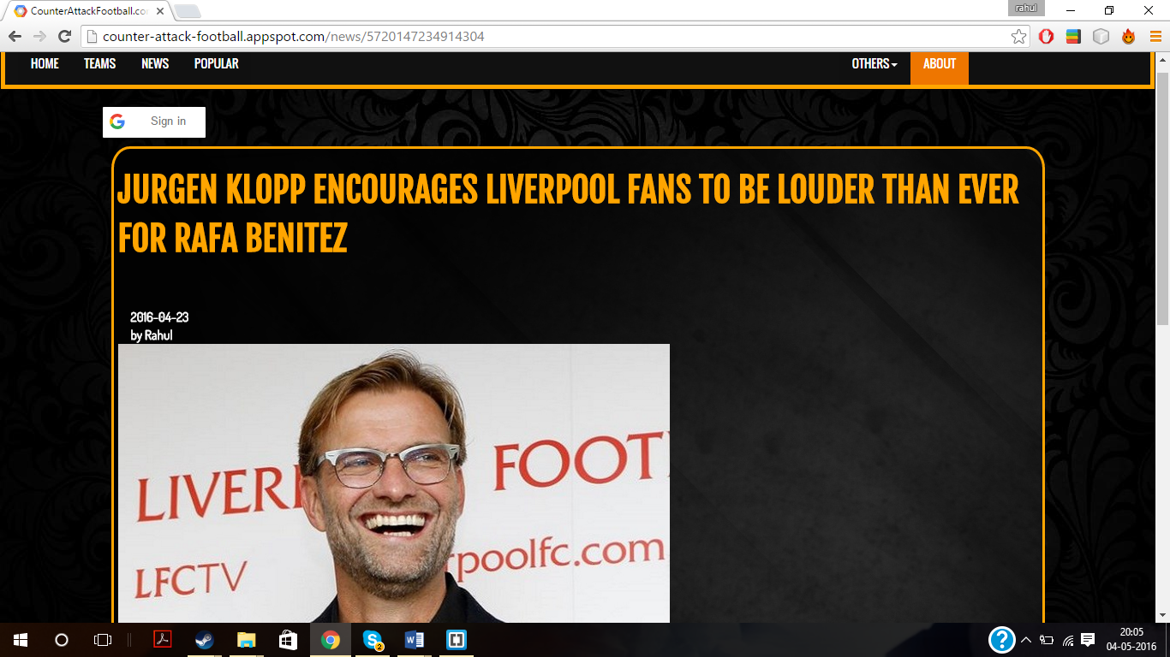

**RSS FEEDS:**

<div class = "col-lg-12">

<div class="g-signin2" data-onsuccess="onSignIn"></div>

<script type="text/javascript">document.write('\x3Cscript type="text/javascript" src="' + ('https:' == document.location.protocol ? 'https://' : 'https://') + 'feed.mikle.com/js/rssmikle.js">\x3C/script>');</script><script type="text/javascript">(function() {var params = {rssmikle_url: "https://feeds.bbci.co.uk/sport/0/football/rss.xml?edition=uk",rssmikle_frame_width: "100%",rssmikle_frame_height: "100%",frame_height_by_article: "100",rssmikle_target: "_blank",rssmikle_font: "Tahoma, Verdana, Segoe, sans-serif",rssmikle_font_size: "20",rssmikle_border: "off",responsive: "off",rssmikle_css_url: "",text_align: "left",text_align2: "left",corner: "off",scrollbar: "on",autoscroll: "off",scrolldirection: "up",scrollstep: "0",mcspeed: "0",sort: "New",rssmikle_title: "on",rssmikle_title_sentence: "LATEST NEWS",rssmikle_title_link: "",rssmikle_title_bgcolor: "#ffa500",rssmikle_title_color: "#F5EFEB",rssmikle_title_bgimage: "",rssmikle_item_bgcolor: "none",rssmikle_item_bgimage: "",rssmikle_item_title_length: "80",rssmikle_item_title_color: "#ffa500",rssmikle_item_border_bottom: "on",rssmikle_item_description: "on",item_link: "off",rssmikle_item_description_length: "150",rssmikle_item_description_color: "#FFFFFF",rssmikle_item_date: "on",rssmikle_timezone: "Asia/Calcutta",datetime_format: "%b %e, %Y %l:%M %p %Z",item_description_style: "text",item_thumbnail: "crop",item_thumbnail_selection: "auto",article_num: "100",rssmikle_item_podcast: "off",keyword_inc: "",keyword_exc: ""};feedwind_show_widget_iframe(params);})();</script>

<div style="font-size:10px; text-align:center; width:100%; opacity: 0.5"><a href="https://feed.mikle.com/" target="_blank" style="color:#CCCCCC;"> RSS Feed Widget</a><!--Please display the above link in your web page according to Terms of Service.--></div><!-- end feedwind code --><!-- end feedwind code -->

</div>

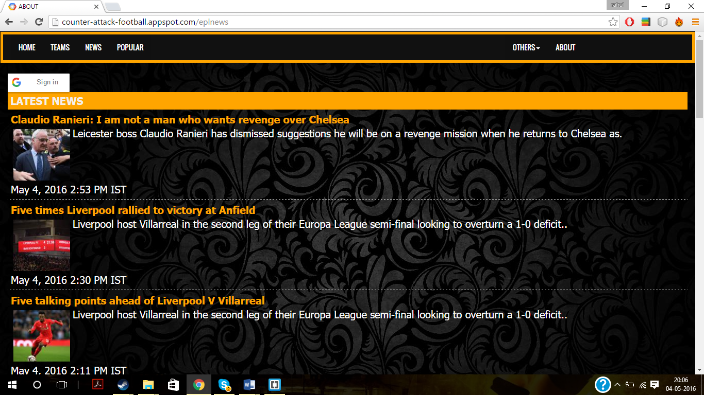

***MAIN.PY***

#!/usr/bin/env python

#

# Copyright 2007 Google Inc.

#

# Licensed under the Apache License, Version 2.0 (the "License");

# you may not use this file except in compliance with the License.

# You may obtain a copy of the License at

#

# https://www.apache.org/licenses/LICENSE-2.0

#

# Unless required by applicable law or agreed to in writing, software

# distributed under the License is distributed on an "AS IS" BASIS,

# WITHOUT WARRANTIES OR CONDITIONS OF ANY KIND, either express or implied.

# See the License for the specific language governing permissions and

# limitations under the License.

#

import webapp2

import os

import jinja2

import re

import logging

from google.appengine.ext import db

from google.appengine.api import users

from google.appengine.api import images

from datetime import datetime

import urllib2

import time

import json

template_dir = os.path.join(os.path.dirname(__file__),'templates')

jinja_env = jinja2.Environment(loader = jinja2.FileSystemLoader(template_dir),

autoescape=True)

class Handler(webapp2.RequestHandler):

def write(self,*a,**kw):

self.response.out.write(*a,**kw)

def render_str(self,template,**params):

t = jinja_env.get_template(template)

return t.render(params)

def render(self,template,**kw):

self.write(self.render_str(template,**kw))

class MainHandler(Handler):

def get(self):

adata = article.gql("order by created desc limit 6")

self.render("Project.html",adata = adata)

class article(db.Model):

headline = db.StringProperty(required = True)

sideheadline = db.StringProperty()

content = db.TextProperty(required = True)

created = db.DateProperty(auto_now_add = True)

author = db.TextProperty()

picture = db.StringProperty()

views = db.IntegerProperty(default=0)

class WriteFormHandler(Handler):

def get(self):

self.render("WriteForm.html")

def post(self):

headline = self.request.get("headline")

content = self.request.get("content")

author = self.request.get("author")

sideheadline = self.request.get("sideheadline")

if self.request.get('picture'):

picture = self.request.get('picture')

else:

picture = "https://kabekin.com/en/uploads/converted/15/05/09/1881465928-fc-barcelona-soccer-football-crowd-stadium-people-1920x1200-g5NZ-g5NZ-1334x750-MM-100.jpg"

a = article(headline = headline,content =content,author = author,picture = picture,sideheadline = sideheadline)

a.put();

self.redirect('/news')

class TeamsHandler(Handler):

def get(self):

self.render("teams.html")

class ArticleHandler(Handler):

def get(self,post_id):

data = article.get_by_id(int(post_id))

data.views = data.views + 1

data.put()

self.render("NewsTemplate.html",data = data)

class AboutHandler(Handler):

def get(self):

self.render("About.htm")

class RSSHandler(Handler):

def get(self):

self.render("rssfeeds.html")

class TeamsheetHandler(Handler):

def get(self):

self.render("Teamsheet.html")

class NewsHandler(Handler):

def get(self):

adata = article.gql("order by created desc")

self.render("news.html",adata = adata)

def post(self):

date1 = self.request.get("datebox")

sortype = self.request.get("sorting")

if date1 == "":

date1 = "2016-01-01"

dateobj = datetime.strptime(date1, '%Y-%m-%d')

x = "where created >= DATE('" + date1 + "')" + " order by " + sortype

adata = article.gql(x)

self.render("news.html",adata = adata)

class RSSplHandler(Handler):

def get(self):

self.render("premierleaguerss.html")

class RSSuclHandler(Handler):

def get(self):

self.render("Championsleaguerss.html")

class RSSIntHandler(Handler):

def get(self):

self.render("InternationalFootball.html")

class LiveScoreHandler(Handler):

def get(self):

self.render("Livescores.html")

class fbHandler(Handler):

def get(self):

self.render("fbtest.html")

class PopularNewsHandler(Handler):

def get(self):

adata = article.gql("order by views desc limit 6")

self.render("mostread.html",adata = adata)

app = webapp2.WSGIApplication([

('/', MainHandler),('/teams',TeamsHandler),('/about',AboutHandler),('/teamsheet',TeamsheetHandler),('/article',WriteFormHandler),('/news',NewsHandler),('/allnews',RSSHandler),('/uclnews',RSSuclHandler),('/Internationalnews',RSSIntHandler),('/eplnews',RSSplHandler),('/livescores',LiveScoreHandler),('/popular',PopularNewsHandler),(r'/news/(\d+)',ArticleHandler),('/fb',fbHandler)], debug=True)

